Mathematical Modeling (Home Work # 2)

Alvina Arshad

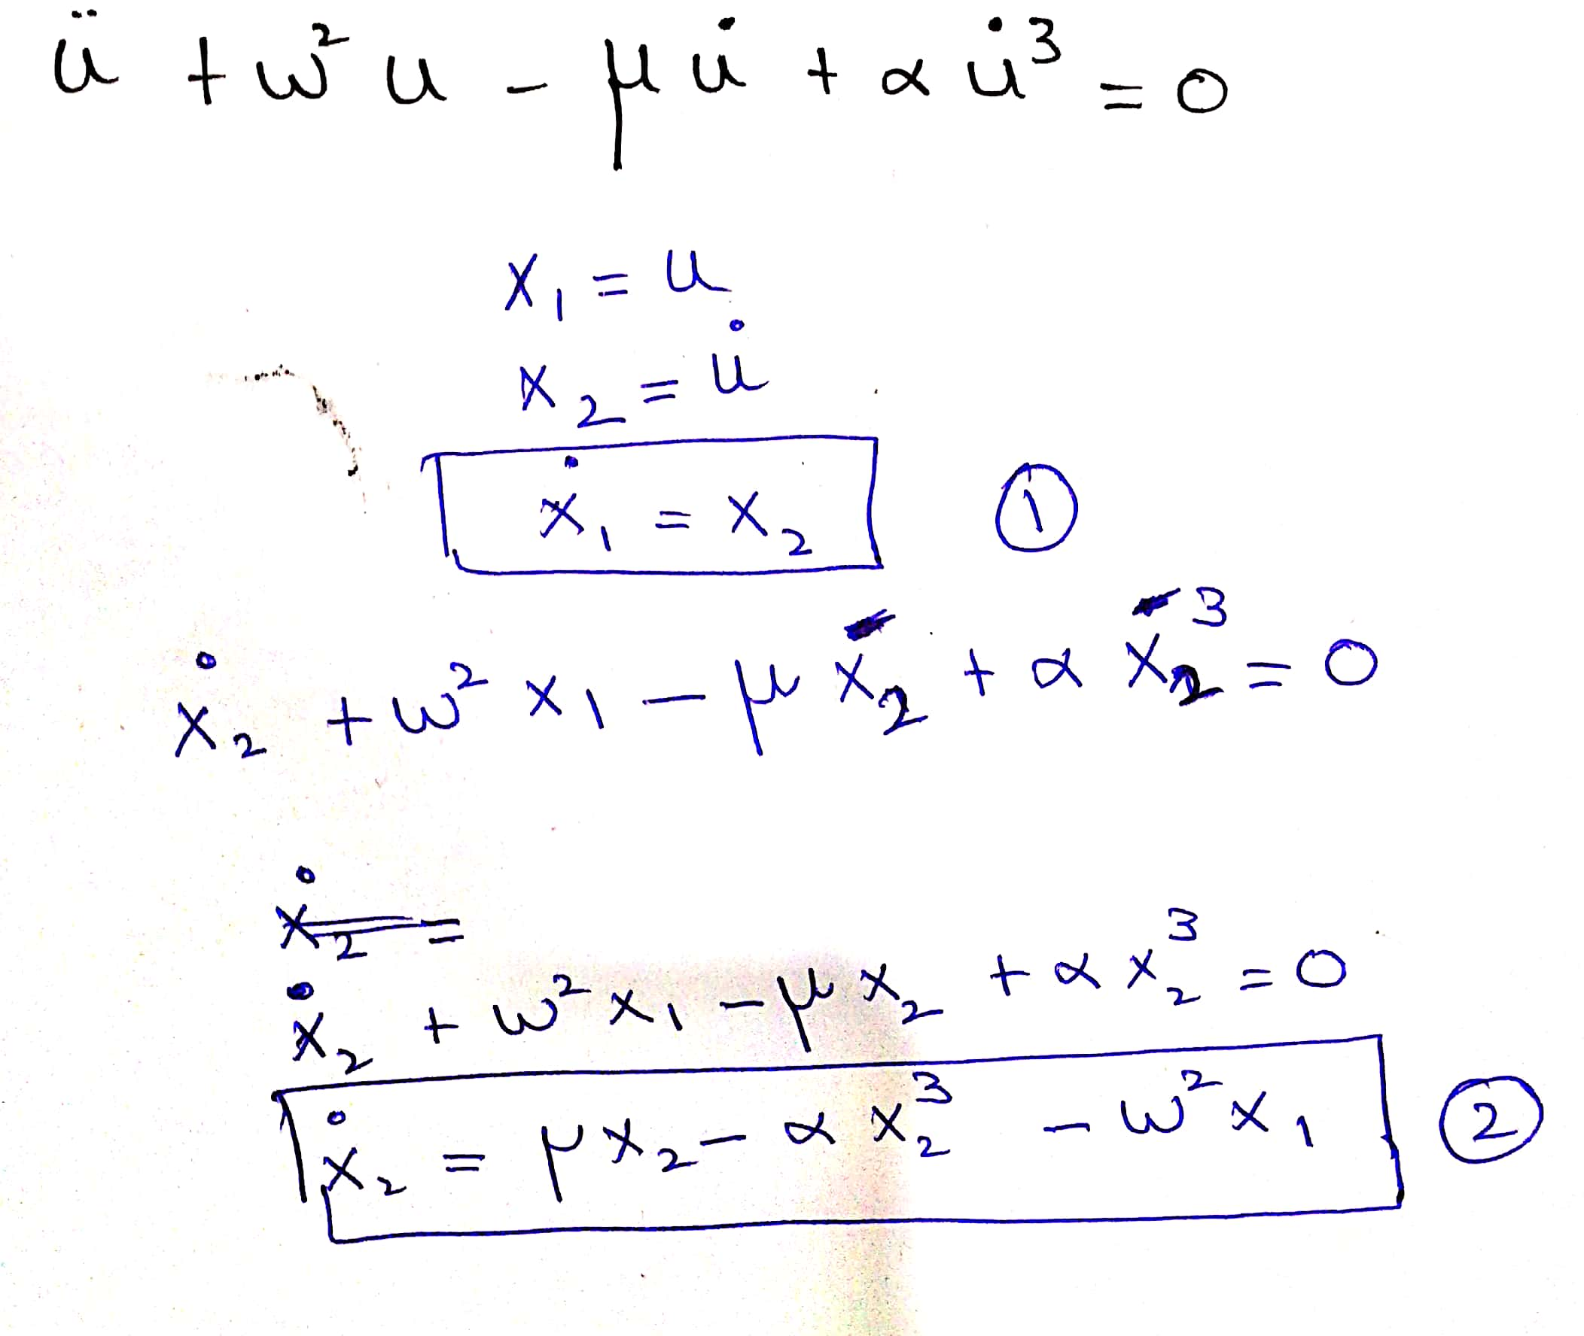



**Graphs**

Let $w=0.4,$

$$α=0.2$$

$$μ=100$$

**Time Series Plot**

**Code:**

[t,y] = ode45(@na,[0 20],[1; 0]);

plot(t,y(:,1),t,y(:,2))

title('Plot');

xlabel('t');

ylabel('y');

**Initial conditions 1 and 0**

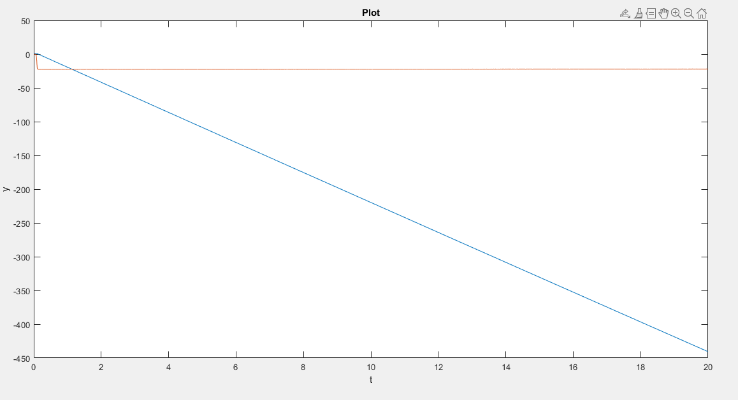

**Phase Portrait Plots**

**Code:**

[X1,X2] = meshgrid(-10:0.5:10);

xs = arrayfun(@(x,y) {odeFun([],[x,y])}, X1, X2);

x1s = cellfun(@(x) x(1), xs);

x2s = cellfun(@(x) x(2), xs);

quiver(x1s, x2s)

xlabel('x_1')

ylabel('x_2')

axis tight equal;

function dxdt = odeFun(t,x)

w = 0.4;

mu = 100;

alpha = 0.2

dxdt(1) = x(2);

dxdt(2) = mu*x(2) - alpha*x(2)^3 - w^2*x(1);

end

